**Unit 1 Guided Practice 3**

These questions come from the tasks in Chapter 2 of the textbook (Sections 2-9 through 2-19). Please enter the queries in the Query Window, include a comment with your full name, run the Query, take a screen shot of the Query and the Output, and paste it into a Word document.

Question 1

Write a query listing all employees who do not report to employee 203, Martha Woods. Show the following columns:

*employee_id*

*first_name*

*last_name*

*manager_id*

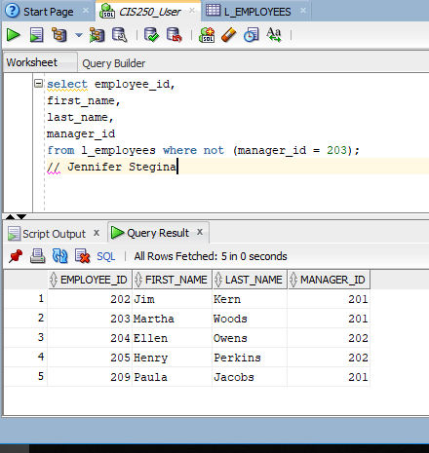

Question 2

Write a query listing all employees who report to employees 202 or 203, Jim Kern or Martha Woods. Show the following columns:

*employee_id*

*first_name*

*last_name*

*manager_id*

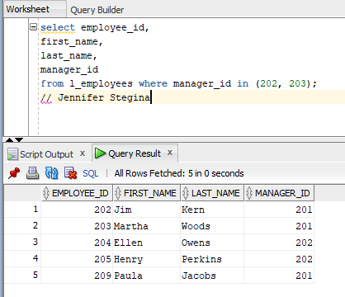

Question 3

Write a query showing another way to write the same query. Use two Equal conditions combined together with a Boolean *or*.

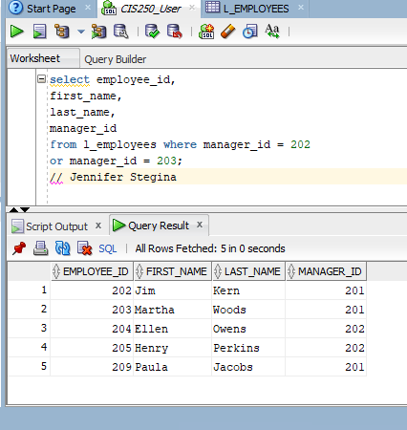

Question 4

Write a query listing all employees hired between August 16, 1999, and July 1, 2008. Show the following columns:

*employee_id , first_name , last_name , hire_date*

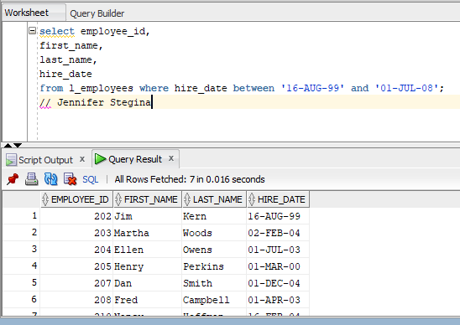

Question 5

Write the same query as in the preceding task with an *in* condition. This requires you to write about 3,300 dates and demonstrates the usefulness of the *between* condition. Even when the code can be written in another way, the code is more compact and less prone to errors when the between condition is used.

NOT TYPING 3K+ LINES OF CODE. I typed a bunch though.

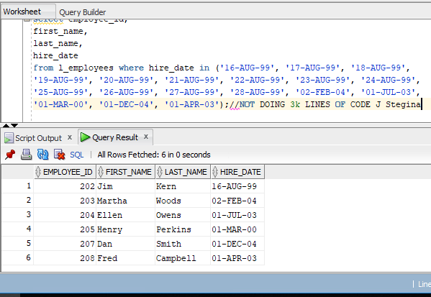

Question 6

Write a query listing employee ID, first name, and last name of the employees that have an employee ID between 201 and 205.

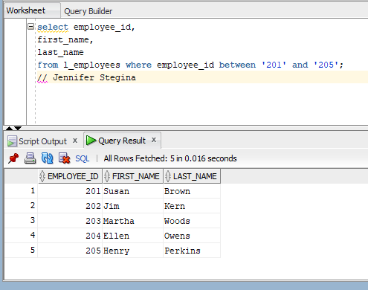

Question 7

List all employees who have the letter *n* in their last name. Show the following columns:

*employee_id, first_name, last_name*

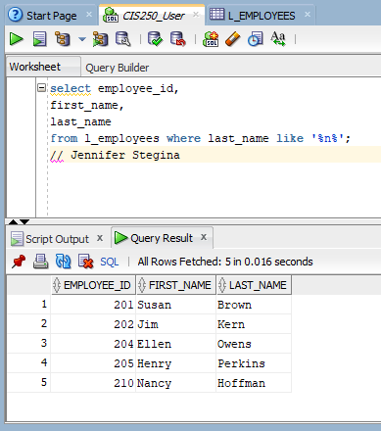

Question 8

Write a query listing all employees who have a null in the *manager_id* column. Show the following columns:

*employee_id, first_name, last_name, manager_id*

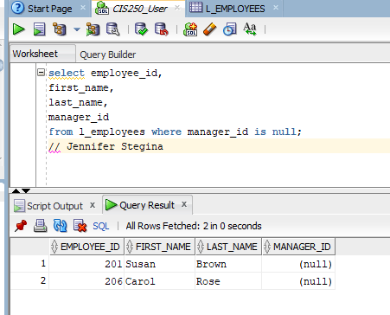

Question 9

Write a query listing the last name and first name of all the employees in the *l_employees* table. Rename the *last_namecolumn* to *family_name*. Sort the rows by the *last_name* column in ascending order. Show how to do this using the two methods of specifying the column to sort on.

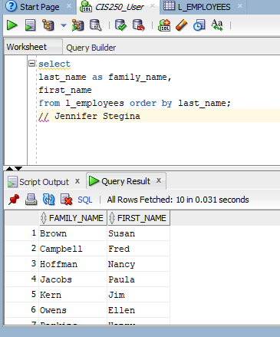 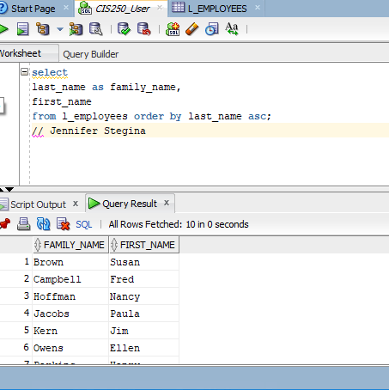

Question 10

Write a query listing the department codes and last names of all the employees, except for employee 209. Sort the rows of the result table on both columns in ascending order.

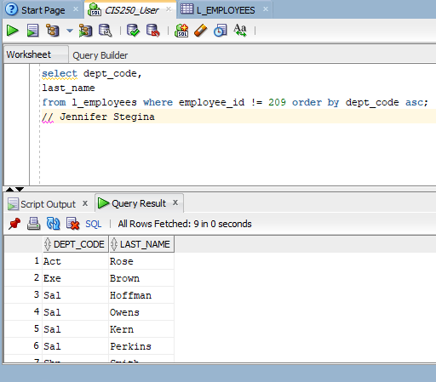

Question 11

The table sec0218 has two columns named A and B. Each column contains the numbers 1, 2, and 3. The table has nine rows showing all the combinations of values.

Write a query listing all the columns of this table. Sort the rows in two ways:

1. First by column A, then by column B.

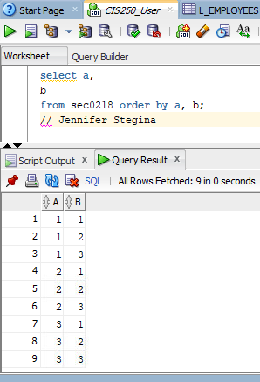

1. First by column B, then by column A.

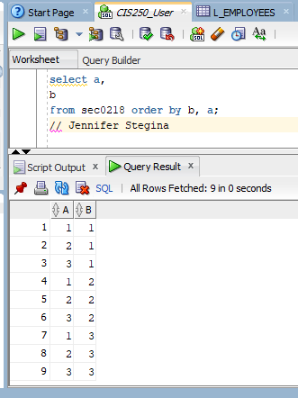

Observe the difference in the result.

The results are like a mirror image of the previous result. 111222333 on the far left at the start and then 111222333 on the far right in the second query.

After you are finished, please submit the Microsoft Word file that contains screenshots of the SQL script and the output. Make sure you include a comment line with your name in the Query Windows. Your document should be named **U1_GuidedPractice3_Lastname.docx**.